API Communication and JSON Handling in Python
Objective
To learn how Python communicates with external APIs using the Requests library and how to parse and filter JSON data.
Tools Used
- Python
- requests library
- Public REST API
Concepts Used
- Sending HTTP GET request
- Handling JSON response
- Filtering data
- Exception handling
- Status code checking
API Used
https://jsonplaceholder.typicode.com/users
This API provides sample user data in JSON format.
Program Explanation
Step 1: Send Request
Python
response = requests.get(url)
Sends request to API.
Step 2: Check Status Code
Python
if response.status_code == 200:
200 means success.
Step 3: Parse JSON
Python
users = response.json()
Converts JSON into Python list of dictionaries.
Step 4: Apply Filter Logic
User enters a city name.
Program filters users based on:
Python
user["address"]["city"]
Step 5: Handle Errors
Python
except requests.exceptions.RequestException as e:
Prevents program crash if API fails.
Source Code
# =====================================
# Task 2: API Communication & JSON Handling
# =====================================

# Import required library
import requests

# -------------------------------------
# Function to Fetch Data from API
# -------------------------------------
def fetch_users():
try:
# API endpoint
url = "https://jsonplaceholder.typicode.com/users"

# Send GET request to API
response = requests.get(url)

# Check if request was successful
if response.status_code == 200:
print("✅ Successfully fetched data from API.\n")

# Convert JSON response into Python list
users = response.json()

return users

else:
print("❌ Failed to fetch data. Status Code:", response.status_code)
return None

except requests.exceptions.RequestException as e:
print("❌ API Request Error:", e)
return None

# -------------------------------------
# Function to Filter Users by City
# -------------------------------------
def filter_by_city(users, city_name):
print(f"\n🔎 Users from {city_name}:\n")

found = False

for user in users:
if user["address"]["city"].lower() == city_name.lower():
print("Name:", user["name"])
print("Email:", user["email"])
print("-" * 30)
found = True

if not found:
print("No users found in this city.")

# -------------------------------------
# Main Program
# -------------------------------------
def main():
users = fetch_users()

if users:
city = input("Enter city name to search users: ")
filter_by_city(users, city)

# Run program
if __name__ == "__main__":
main()
Sample Output
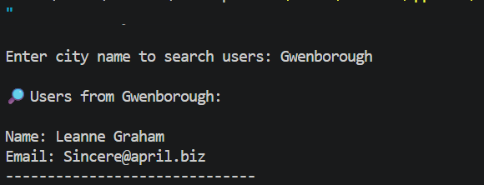
Project Link:
https://github.com/nandinivetcha-hub/python-api-handling-task2.git

